Git command and their ouputs

- Initialize git

- Create Directory and add into staging area

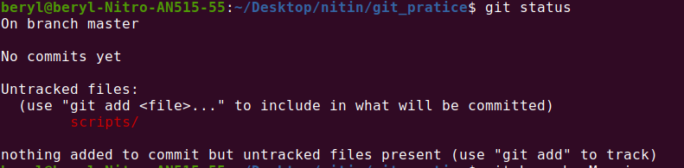
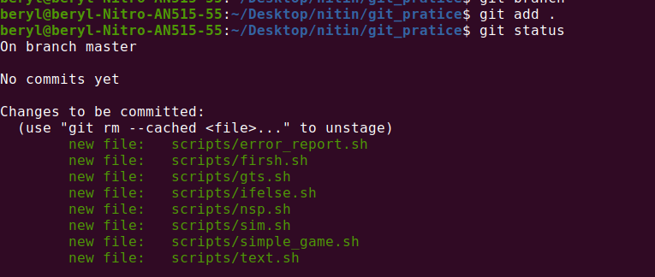

- Commit “initial commit”
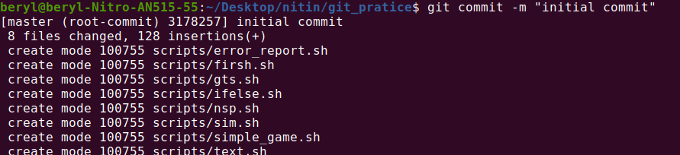
- Check the log
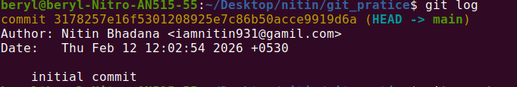

- Check if working directory is connected with main repo.

- Then push all the files into main Repo.

- Create a temporary directory and add in staging area, commit and push into repo.
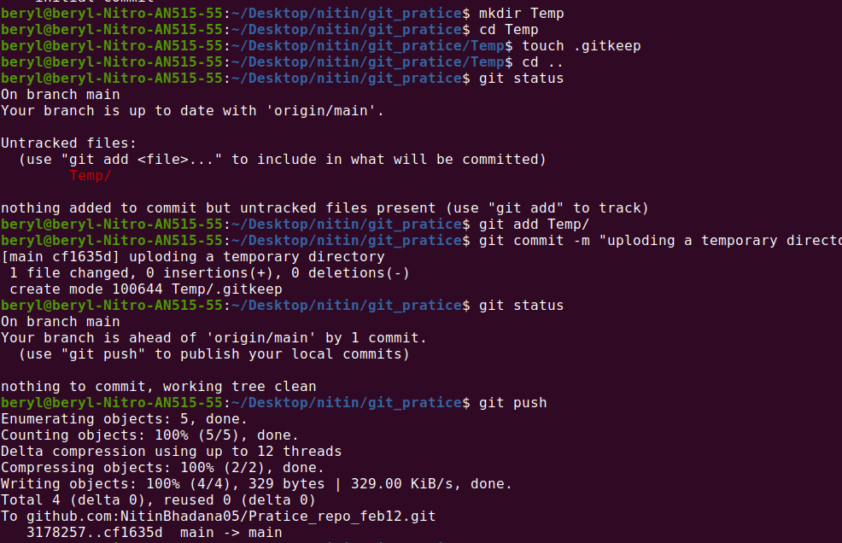
- Removing the Temp dir from main Repo
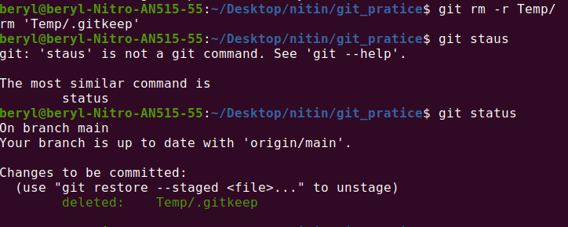

- Modify a single file and add, commit and push it into Repo.
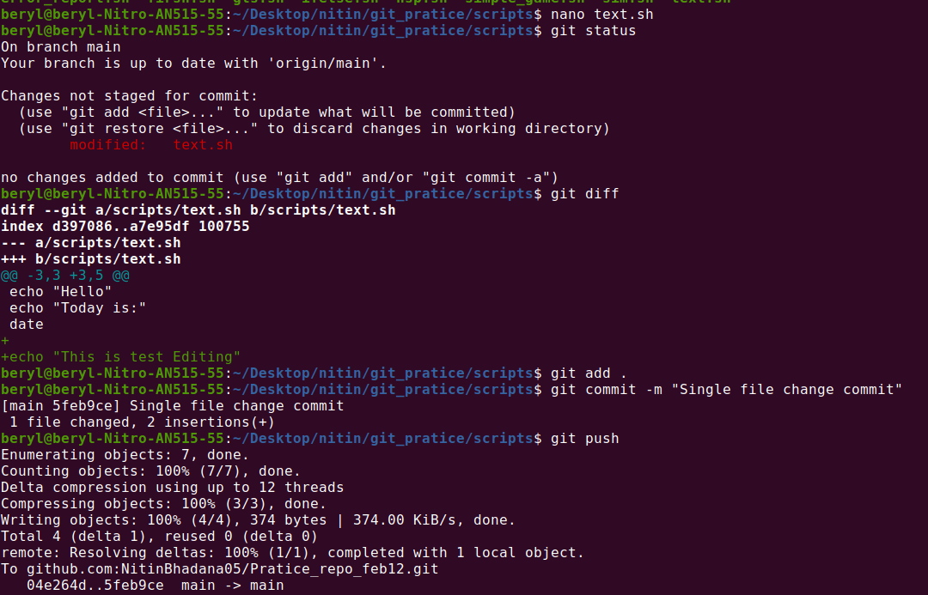

- Modify multiple files and commit into Repo.
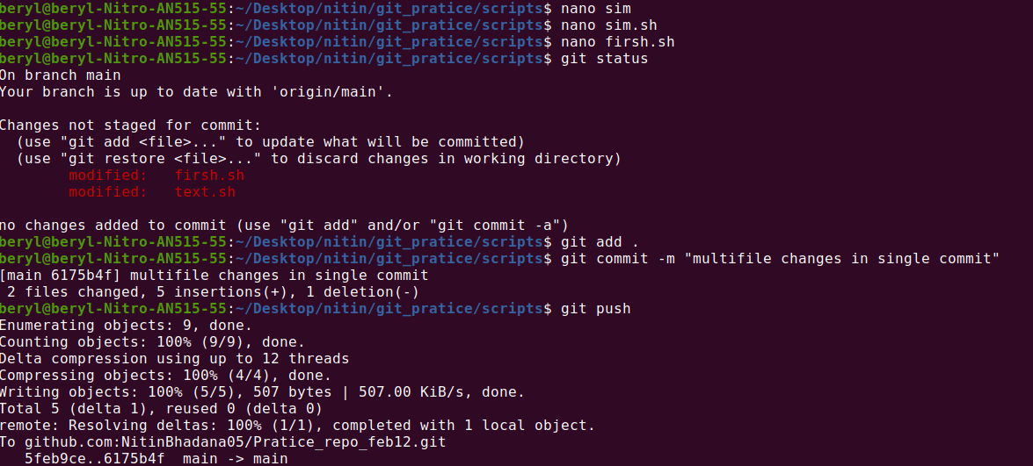

- Switch to new branch and add new file and check log
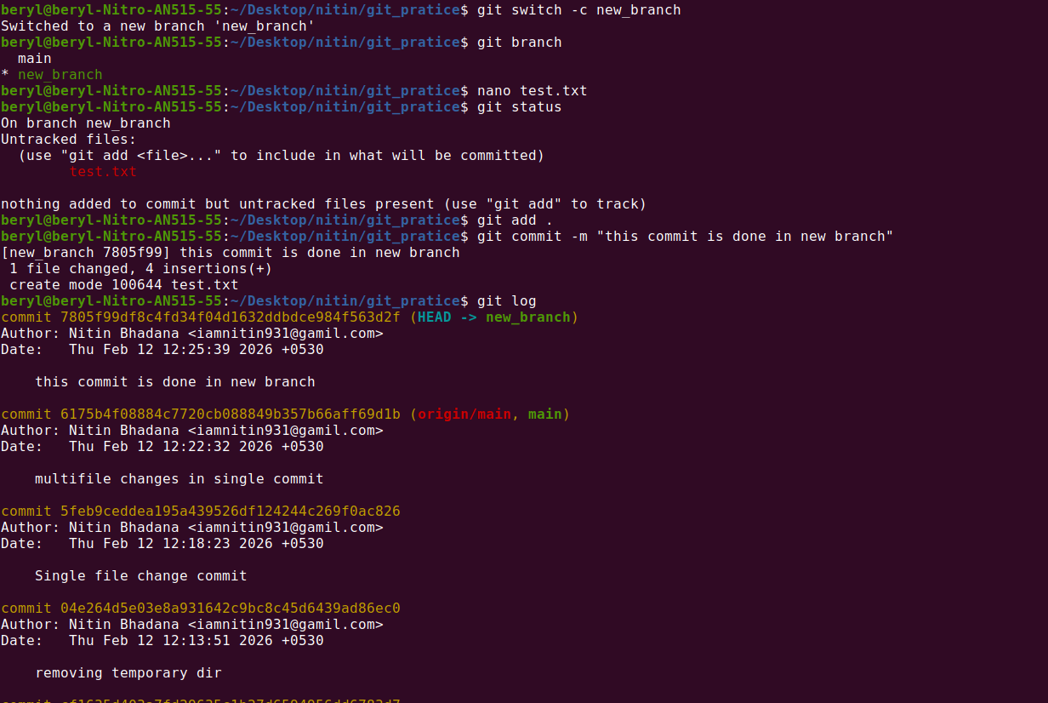

- Merger both branches
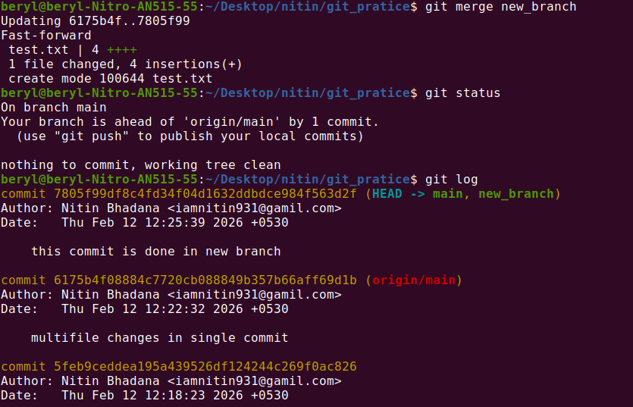

- Crate a merge conflict
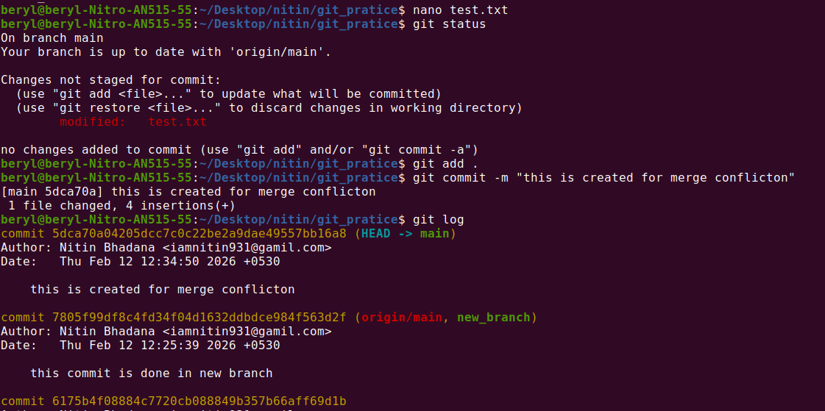

- Conflict occur when merging
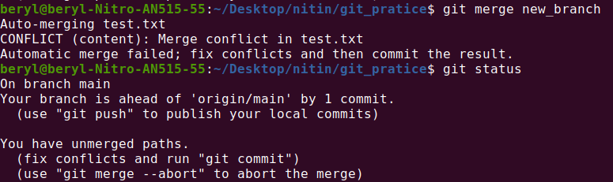
- Resolving the conflict
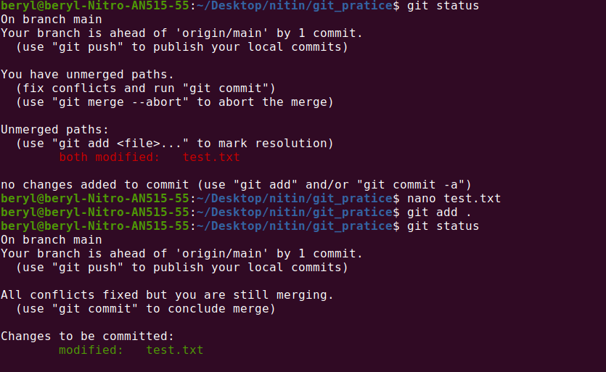

- Create new branch add new file
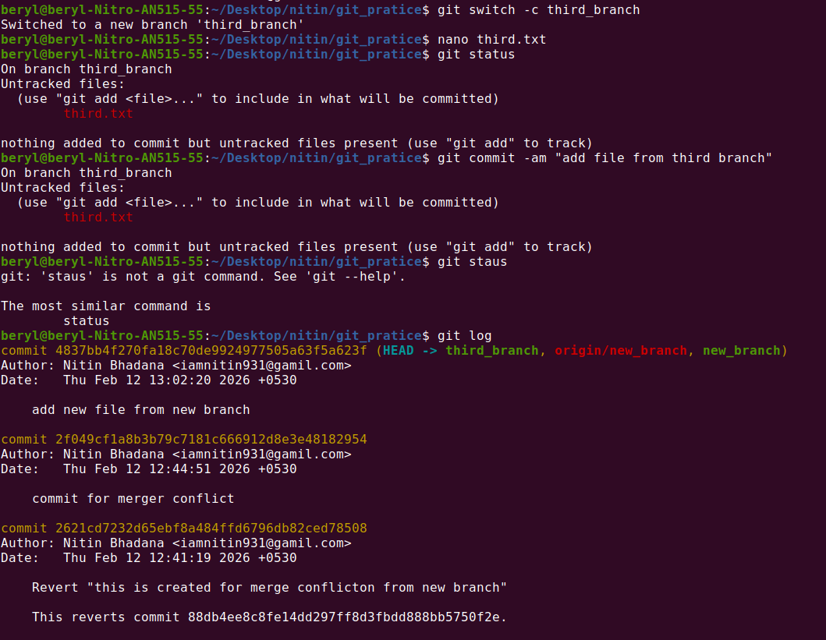
- Push all files into Repo

